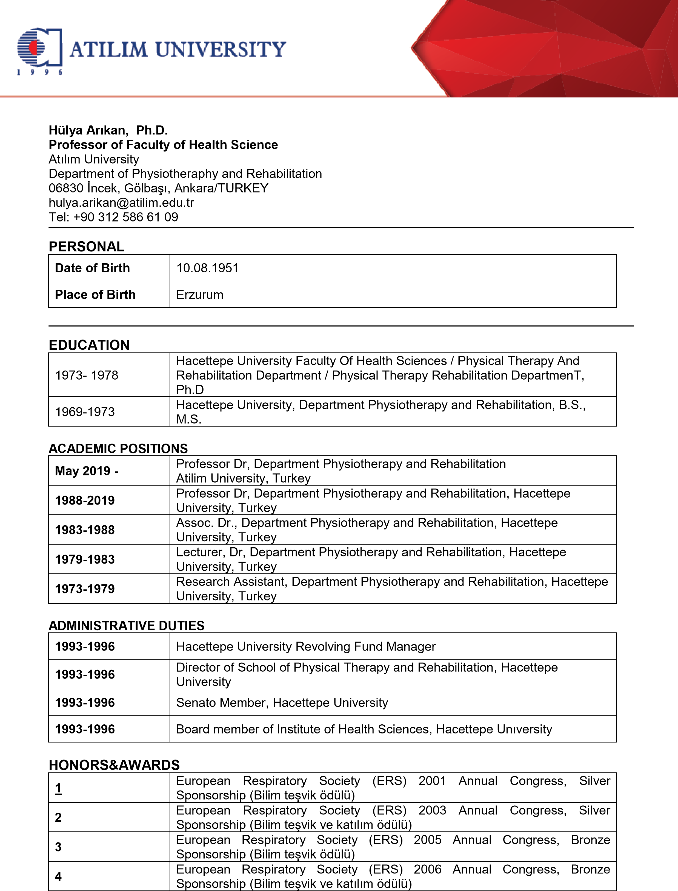

Sema Nur Aslan, Pt

Research Assistant  
Atilim University  
Faculty of Health Sciences,  
Department of Physiotherapy and Rehabilitation 06830, İncek, Gölbaşı, Ankara/TURKEY

[sema.aslan@atilim.edu.tr](mailto:sema.aslan@atilim.edu.tr)

Tel : +90 312 586 6326

PERSONAL

|  |  |
| --- | --- |
| Date of Birth | 19.03.1999 |
| Place of Birth | Malatya |

EDUCATION

|  |  |
| --- | --- |
| 2018-2022 | Inonu University, Faculty of Health Sciences, Physiotherapy and Rehabilitation, BsC |
| 2022-2024 | Hacettepe University, Institute of Health Sciences, Orthopedic Physiotherapy and Rehabilitation, MsC |
| 2025-Still | Hacettepe University, Institute of Health Sciences, Orthopedic Physiotherapy and Rehabilitation, PhD |

ACADEMIC POSITIONS

|  |  |
| --- | --- |
| October 2023 – Still | Research Assistant, Department of Physiotherapy and Rehabilitation, Atilim University |

RESEARCH INTERESTS

|  |
| --- |
| Physical Therapy and Rehabilitation, Orthopedic Rehabilitation, Telerehabilitation |

PUBLICATIONS AND PRESENTATIONS

|  |  |
| --- | --- |
| 1 | Aslan S.N., Gevrek C., Demirel M.*, Atilla B., Kinikli GI.* POS1482-HPR COMPARISON OF THE EFFECTIVENESS OF TELEREHABILITATION IN INDIVIDUALS WITH OSTEOARTHRITIS FOLLOWING TOTAL KNEE ARTHROPLASTY: RANDOMIZED CONTROLLED TRIAL. *Annals of the Rheumatic Diseases,EULAR, Vienne,*2024;83:1194-1195. |
| 2 | Kinikli G.I., Demirtunc Sevim D., Aslan S.N.*, et al.* AB1621-HPR PREDICTORS OF KINESIOPHOBIA IN INDIVIDUALS WITH OSTEOARTHRITIS FOLLOWING UNILATERAL KNEE ARTHROPLASTY. *Annals of the Rheumatic Diseases,EULAR, Vienne, 2024*;83:2186. |
| 3. | *Aslan S.N., Gevrek C., Demirel M., et al.* EVALUATION OF THE SHORT-TERM EFFECTIVENESS OF TELEREHABILITATION ON PAIN AND FUNCTION IN INDIVIDUALS WITH TOTAL KNEE ARTHROPLASTY: A RANDOMIZED CONTROLLED TRIAL, International Congress on Physiotechnotherapy, Alexandropoli, 2024 |
| 4. | *Ulug N., Korkusuz S., Beyazkilic N.B., Tosun E., Saniei G., Rahimikia M., Sadeghzadeh K., Korkusuz B., Aslan S.N., Changes in Thoracolumbar Fascia Stiffness and Pain Parameters in Patients with Chronic Low Back Pain, IASP World Congress on Pain, 2024.* |

PROJELER

|  |  |
| --- | --- |
| 1 | Prof. Dr. Erden KILIÇ, Fzt. Sema Nur ASLAN, Rotator Cuff Yaralanmalarında Yaralanma Seviyesi ile Scapula Rotasyonu Arasındaki İlişkinin İncelenmesi-ATÜ-LAP-2324-06 |
| 2 | Prof. Dr. Gizem İrem KINIKLI, Dr. Fzt. Ferhat ÖZTÜRK, Uzm. Fzt. Cansu GEVREK ASLAN, Fzt. Sema Nur ASLAN, Farklı Enstrüman Çalan Müzisyenlerde Kas Kuvveti, Denge, Postür, Eklem Hareket Açıklığı, Propriyosepsiyon ve Ağrı Arasındaki İlişkinin İncelenmesi |
| 3 | Dr. Öğr. Üyesi Naime ULUĞ, Uzm. Fzt. Sema Nur ASLAN, Patellofemoral Ağrı Sendromu Olan Bireylerde Femur-Patella Arasındaki Uzaklığın Klinik Semptomlar Üzerine Olan Etkisinin Araştırılması-ATÜ-LAP2425-32 |